- Path to configure postgres wal

| path | /var/lib/postgresql/data/postgresql.conf |
| --- | --- |

- How on **WINDOWS** looks when we download for the first time

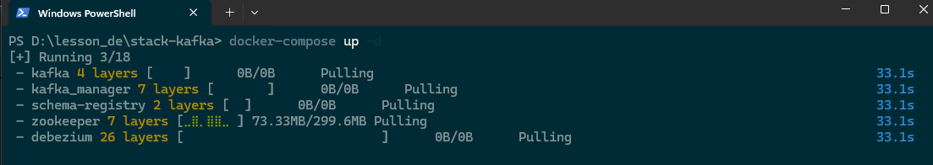

| **file** | docker-compose.yaml |
| --- | --- |
| version: "3.7"  services:  zookeeper:  image: confluentinc/cp-zookeeper:5.5.3  environment:  ZOOKEEPER_CLIENT_PORT: 2181  networks:  - belajar_ruby  kafka:  image: confluentinc/cp-enterprise-kafka:5.5.3  depends_on:  - zookeeper  ports:  - 29092:29092  environment:  KAFKA_BROKER_ID: 1  KAFKA_OFFSETS_TOPIC_REPLICATION_FACTOR: 1  KAFKA_ZOOKEEPER_CONNECT: zookeeper:2181  KAFKA_ADVERTISED_LISTENERS: PLAINTEXT://kafka:9092,PLAINTEXT_HOST://localhost:29092  KAFKA_LISTENER_SECURITY_PROTOCOL_MAP: PLAINTEXT:PLAINTEXT,PLAINTEXT_HOST:PLAINTEXT  networks:  - belajar_ruby  debezium:  image: debezium/connect:2.7  environment:  BOOTSTRAP_SERVERS: kafka:9092  GROUP_ID: 1  CONFIG_STORAGE_TOPIC: connect_configs  OFFSET_STORAGE_TOPIC: connect_offsets  # KEY_CONVERTER: io.confluent.connect.avro.AvroConverter  # VALUE_CONVERTER: io.confluent.connect.avro.AvroConverter  CONNECT_KEY_CONVERTER_SCHEMA_REGISTRY_URL: http://schema-registry:8081  CONNECT_VALUE_CONVERTER_SCHEMA_REGISTRY_URL: http://schema-registry:8081  depends_on: [kafka]  ports:  - 8083:8083  networks:  - belajar_ruby  schema-registry:  image: confluentinc/cp-schema-registry:5.5.3  environment:  - SCHEMA_REGISTRY_KAFKASTORE_CONNECTION_URL=zookeeper:2181  - SCHEMA_REGISTRY_HOST_NAME=schema-registry  - SCHEMA_REGISTRY_LISTENERS=http://schema-registry:8081,http://localhost:8081  ports:  - 8081:8081  depends_on: [zookeeper, kafka]  networks:  - belajar_ruby    kafka_manager:  image: hlebalbau/kafka-manager:stable  restart: always  ports:  - "9000:9000"  depends_on:  - zookeeper  - kafka  environment:  ZK_HOSTS: "zookeeper:2181"  APPLICATION_SECRET: "random-secret"  command: -Dpidfile.path=/dev/null  networks:  - belajar_ruby  networks:  belajar_ruby:  driver: bridge | |

Docker command to attach network

| –connect  docker network connect [network_name] [container_name]  –disconnect  docker network disconnect [network_name] [container_name] |
| --- |

Some basic **KAFKA** useful command:

| --create topic  kafka-topics --create --topic test --bootstrap-server localhost:9092 --partitions 1 --replication-factor 1  --list kafka topics  kafka-topics --bootstrap-server=localhost:9092 --list  --start console proudcer and send messages  kafka-console-producer --topic test --bootstrap-server localhost:9092  --start console consumer and receive messages  kafka-console-consumer --topic test --from-beginning --bootstrap-server localhost:9092 |
| --- |

**STEP ON KAFKA MANAGER**

1. Access <https://localhost:9000>
2. Following default sample, and click save.

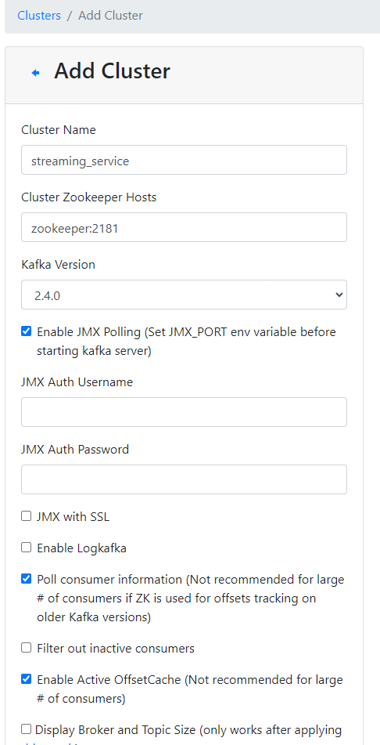

1. Create topic by the kafka cluster  
   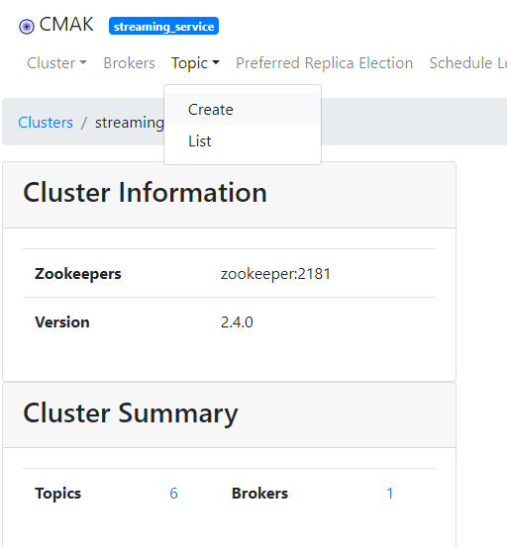
2. Create the topic and let it remain default, save.

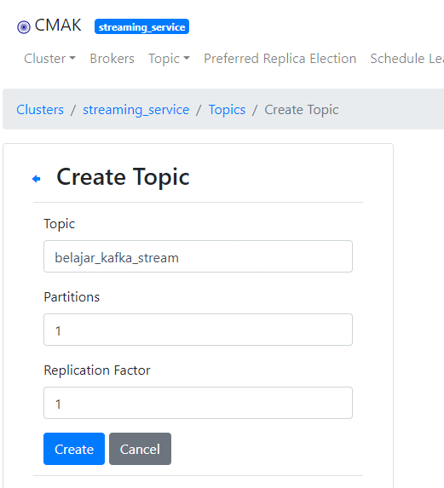

1. Remain try the testing producer and consumer methods

**STEP ON DEBEZIUM CONNECTOR**

Point interact with REST Client at <http://localhost:8083>,

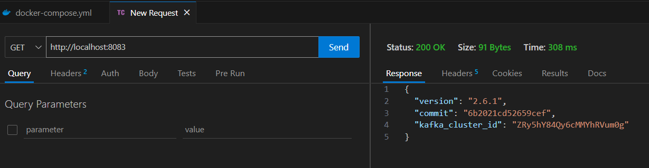

| **GET** LIST OF CONNECTORS | http://localhost:8083/connectors |
| --- | --- |
| **GET** DEBEZIUM INITIAL | http://localhost:8083 |
| **POST** CREATE CONNECTOR | http://localhost:8083/connectors |

| json body for CREATE CONNECTOR |
| --- |
| {  "name": "source-sales-data-connector-",  "config": {  "connector.class": "io.debezium.connector.postgresql.PostgresConnector",  "database.hostname": "belajar_postgres",  "database.port": "5432",  "database.user": "postgres",  "database.password": "password",  "database.dbname": "postgres",  "plugin.name": "pgoutput",  "database.server.name": "source",  "key.converter.schemas.enable": "false",  "value.converter.schemas.enable": "false",  "transforms": "unwrap",  "transforms.unwrap.type": "io.debezium.transforms.ExtractNewRecordState",  "value.converter": "org.apache.kafka.connect.json.JsonConverter",  "key.converter": "org.apache.kafka.connect.json.JsonConverter",  "table.include.list": "public.sales_data",  "slot.name" : "sales_data_slot",  "topic.prefix" : "sd"  }  } |

**CLICKHOUSE** Part

- deploy local

| docker run -d -p 18123:8123 -p 19000:9000 -e CLICKHOUSE_PASSWORD=password --name belajar_ch --ulimit nofile=262144:262144 clickhouse/clickhouse-server |
| --- |

- base table

| CREATE TABLE default.sales_data  (  `date` DateTime,  `name` String,  `market_area` String,  `number_of_sales` UInt32,  `pricing_unit` Float64,  `insert_time_clickhouse` SimpleAggregateFunction(max, Datetime('Asia/Jakarta')) DEFAULT NOW()  )  ENGINE = ReplacingMergeTree  PARTITION BY name  ORDER BY (date, name, market_area)  SETTINGS index_granularity = 8192; |
| --- |

- kafka base table

| CREATE TABLE default.sales_data_queue  (  `date` DateTime,  `name` String,  `market_area` String,  `number_of_sales` UInt32,  `pricing_unit` Float64  )  ENGINE = Kafka  SETTINGS kafka_broker_list = 'stack-kafka-kafka-1:9092',  kafka_topic_list = 'sd.public.sales_data',  kafka_group_name = 'test-1',  kafka_format = 'JSONEachRow'; |
| --- |

- mv to base table

| CREATE MATERIALIZED VIEW default.sales_data_queue_mv TO default.sales_data  AS SELECT  date,  name,  market_area,  number_of_sales,  pricing_unit  FROM default.sales_data_queue; |
| --- |